Task Name: Create a summary on Cloud Computing

Cloud Computing
What is Cloud Computing:
- Cloud computing is the on-demand availability of computer system resources, especially data storage (cloud storage) and computing power, without direct active management by the user.
- There are many resources provided which include tools and applications like data storage, servers, databases, networking, and software.
- Companies that offer all the services mentioned above are called cloud providers. They provide you with the ability to store and retrieve data and run applications, managing them through configuration portals.
- It is the on-demand delivery of IT resources over the Internet with pay-as-you-go pricing. Instead of buying, owning, and maintaining physical data centers and servers, you can access technology services, such as computing power, storage, and databases, on an as-needed basis from a cloud provider.
Who can use cloud computing:
Organizations of every type, size, and industry are using the cloud for a wide variety of use cases, such as data backup, disaster recovery, email, virtual desktops, software development and testing, big data analytics, and customer-facing web applications.
For example, healthcare companies are using the cloud to develop more personalized treatments for patients. Financial services companies are using the cloud to power real-time fraud detection and prevention. And video game makers are using the cloud to deliver online games to millions of players around the world.
Cloud Service Provider Companies:
The cloud service providers host these services in a data center, and users can access these services through cloud provider companies using an Internet connection.

Below are the top Cloud Service Providers –

Amazon Web Services (AWS)
Microsoft Azure
Google Cloud Platform
IBM Cloud Services
VMware Cloud
Oracle cloud
Salesforce
Red Hat
DigitalOcean
Rackspace
Benefits of cloud computing:

Cloud platforms offer some significant benefits today, which are driving businesses to adopt Cloud Computing. Those major benefits include:

Agility: The cloud gives you easy access to a broad range of technologies so that you can innovate faster and build nearly anything that you can imagine. You can quickly spin up resources as you need them–from infrastructure services, such as compute, storage, and databases, to Internet of Things, machine learning, data lakes and analytics, and much more.

You can deploy technology services in a matter of minutes, and get from idea to implementation several orders of magnitude faster than before. This gives you the freedom to experiment, test new ideas to differentiate customer experiences, and transform your business.

Elasticity: With cloud computing, you don’t have to over-provision resources up front to handle peak levels of business activity in the future. Instead, you provision the amount of resources that you actually need. You can scale these resources up or down to instantly grow and shrink capacity as your business needs change.

Deploy globally in minutes: With the cloud, you can expand to new geographic regions and deploy globally in minutes. For example, AWS has infrastructure all over the world, so you can deploy your application in multiple physical locations with just a few clicks. Putting applications in closer proximity to end users reduces latency and improves their experience.

Scalability: In a legacy environment, forecasting demands is a full-time job, but with cloud services, you can easily set up an automated monitoring tool to do the job for you. That information will let you accurately upscale or downscale the rate of work you do depend on the needs.

Accessibility: Cloud Computing allows you to access resources, data, services, and applications from anywhere you want, as long as you are connected to the internet. If you are not connected to the internet, some tools and techniques will allow you to access the cloud whenever needed.

Maintenance: Maintenance of cloud environment is easier because the data is hosted on an outside server maintained by a provider without the need to invest in data center hardware. IT maintenance of cloud computing is managed and updated by the cloud provider's IT maintenance team which reduces cloud computing costs compared with on-premises data centers.

Security: Ensuring that your data is stored in a secure, durable place is a priority for all businesses. The cloud provides highly secure storage for customers’ data, yet letting it be accessed anytime and anyplace that it’s required. Also, all data stored in the cloud is encrypted and secured so that it cannot be tampered with.

Cost savings: The cloud allows you to trade fixed expenses (such as data centers and physical servers) for variable expenses, and only pay for IT as you consume it. Plus, the variable expenses are much lower than what you would pay to do it yourself because of the economies of scale.

Types of cloud computing
Infrastructure as a Service (IaaS):
IaaS contains the basic building blocks for cloud IT. It typically provides access to networking features, computers (virtual or on dedicated hardware), and data storage space. IaaS gives you the highest level of flexibility and management control over your IT resources. It is most similar to the existing IT resources with which many IT departments and developers are familiar.

Example: DigitalOcean, Linode, Amazon Web Services (AWS), Microsoft Azure, Google Compute Engine (GCE), Rackspace, and Cisco Metacloud.

Platform as a Service (PaaS):
PaaS removes the need for you to manage underlying infrastructure (usually hardware and operating systems), and allows you to focus on the deployment and management of your applications. This helps you be more efficient as you don’t need to worry about resource procurement, capacity planning, software maintenance, patching, or any of the other undifferentiated heavy lifting involved in running your application.

Example: AWS Elastic Beanstalk, Windows Azure, Heroku, Force.com, Google App Engine, Apache Stratos, Magento Commerce Cloud, and OpenShift.

Software as a Service (SaaS):
SaaS provides you with a complete product that is run and managed by the service provider. In most cases, people referring to SaaS are referring to end-user applications (such as web-based email). With a SaaS offering, you don’t have to think about how the service is maintained or how the underlying infrastructure is managed. You only need to think about how you will use that particular software.

Example: BigCommerce, Google Apps, Salesforce, Dropbox, ZenDesk, Cisco WebEx, ZenDesk, Slack, and GoToMeeting

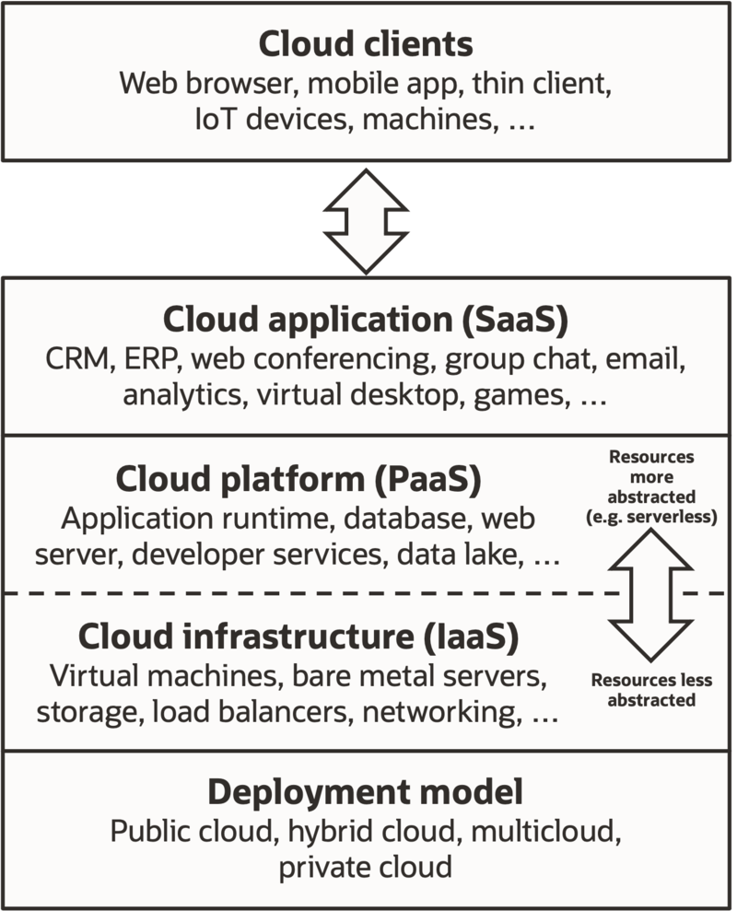
Types of Cloud:

There are the following 4 types of cloud that you can deploy according to the organization's needs-

Public Cloud
Private Cloud
Hybrid Cloud
Community Cloud

Public Cloud:
Public cloud is open to all to store and access information via the Internet using the pay-per-usage method.
In public cloud, computing resources are managed and operated by the Cloud Service Provider (CSP).

Example: Amazon elastic compute cloud (EC2), IBM SmartCloud Enterprise, Microsoft, Google App Engine, Windows Azure Services Platform.

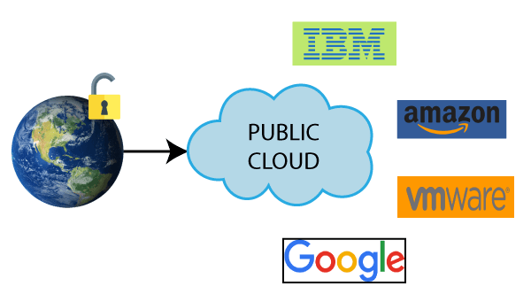
Private Cloud:
Private cloud is also known as an internal cloud or corporate cloud. It is used by organizations to build and manage their own data centers internally or by the third party. It can be deployed using Opensource tools such as Openstack and Eucalyptus.
Based on the location and management, National Institute of Standards and Technology (NIST) divide private cloud into the following two parts-

On-premise private cloud
Outsourced private cloud
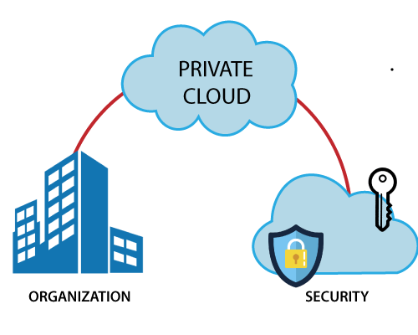
Hybrid Cloud:
Hybrid Cloud is a combination of the public cloud and the private cloud. we can say:

Hybrid Cloud = Public Cloud + Private Cloud
Hybrid cloud is partially secure because the services which are running on the public cloud can be accessed by anyone, while the services which are running on a private cloud can be accessed only by the organization's users.
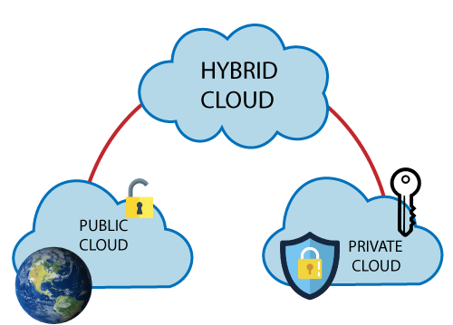

Community Cloud:
Community cloud allows systems and services to be accessible by a group of several organizations to share the information between the organization and a specific community. It is owned, managed, and operated by one or more organizations in the community, a third party, or a combination of them.

Example: Health Care community cloud
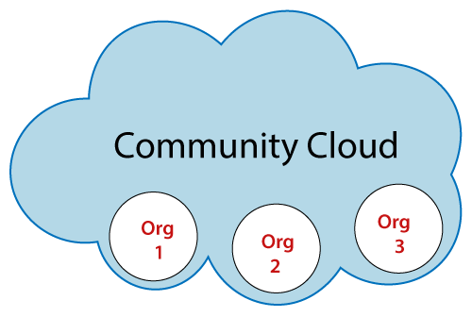
Summary:

- I have described what is Cloud Computing and it’s advantages.
- Types of Cloud Computing with Examples and types of Cloud with features.
- I have done some research and analysis and my secondary research sources include like AWS documentations.

Thank you

